**MemeMagic:**

**AI Meme Generator**

**Submitted By – Yash Raj Anand**

**Project Description:**

MemeMagic is an AI-powered meme generation platform that enables users to effortlessly create humorous, shareable memes from any image. It addresses a common creative hurdle: many users struggle to come up with witty captions that match the tone and context of their images. MemeMagic solves this by combining cutting-edge vision and language models to generate meme-worthy content in real time.

At its core, the system uses Salesforce’s BLIP model (blip-image-captioning-base) to interpret and describe the content of uploaded images. This caption is then passed to Mistral, a fast and lightweight large language model served locally using Ollama, which rewrites the description into a short, funny, meme-style caption. This dual-model pipeline ensures high-quality, context-aware humor that adapts well across diverse meme scenarios.

To further enhance personalization, MemeMagic introduces a **Creativity Level slider**, which adjusts the temperature parameter sent to the Mistral model. This gives users direct control over the randomness and tone of the generated captions. A lower temperature (e.g., 0.2) produces safe, predictable humor, while higher settings (e.g., 1.0) lead to bold, unexpected, and quirky memes. This dynamic tuning allows MemeMagic to cater to a wide range of humor preferences—from subtle wit to chaotic absurdity.

The backend is implemented with FastAPI, providing RESTful endpoints for image upload, caption generation, and meme rendering. The frontend, built with HTML, CSS, and JavaScript, offers a smooth, interactive interface for uploading images, previewing captions, editing text, and rendering the final meme dynamically. The temperature slider is integrated into the UI, allowing real-time adjustment and live feedback of the selected creativity level.

Once the caption is ready, the system uses PIL (Python Imaging Library) to draw the text over the image with stroke styling and smart wrapping for readability. Users can then download the final meme or share it instantly via WhatsApp, Facebook, or Instagram through dynamic sharing buttons.

MemeMagic eliminates the creative and technical friction often associated with meme-making. By automating caption generation, enabling humor-level customization, and providing editing flexibility, it empowers users of all backgrounds to turn any image into a punchline—whether for fun, commentary, or social engagement. It’s fast, local, modular, and designed to make meme creation both smart and simple.

**Scenarios:**

**Scenario 1: Social Media Content Creation for Students & Influencers**

A college student uploads a photo of a dog wearing sunglasses to MemeMagic. The system uses the BLIP model to describe the image as “a dog wearing sunglasses,” and passes this to the Mistral model, which generates a witty caption like “When you debug one line and feel like a genius.” The backend overlays this text on the image using PIL and instantly renders the meme on the frontend. The student shares it on Instagram and gets high engagement.  
This scenario highlights how MemeMagic can be used by **content creators, influencers, or students** to quickly generate entertaining posts for platforms like Instagram, X (Twitter), or Snapchat, without needing graphic design skills or creativity overload.

**Scenario 2: Workplace Communication & Team Culture Boost**

An office worker uploads a screenshot of a dull virtual meeting. Instead of using the AI-generated caption, they type their own: “This could’ve been an email.” MemeMagic processes the image, overlays the custom caption, and returns a professional-looking meme for download.  
 In a corporate setting, this tool can be used for **team newsletters, Slack jokes, or internal engagement campaigns** to break monotony, encourage humor in remote teams, and build light-hearted culture without needing creative departments.

**Scenario 3: Viral Marketing & Meme-Based Brand Engagement**

A digital marketing intern at a startup uses MemeMagic to generate a meme from a trending image template. After the meme is created, the system provides one-click share buttons for WhatsApp and Facebook, embedding the image URL and caption. The intern shares it in a brand group and it gets re-shared by customers.  
This scenario demonstrates how MemeMagic can be adopted in **marketing, advertising, and brand management** teams to create viral meme content that resonates with online audiences, increasing brand visibility and engagement.

**Technical Architecture:**

User Frontend

(index.html + JS UI)

JavaScript (app.js)

Handles image upload & API

Call to backend + UI update

FastAPI Backend (main.py)

-CORS setup

-Include meme.py route

Meme Router (meme.py)

-Accepts uploaded image

-Calls caption generator

- Calls image editor

BLIP Model

(BLIP captioning from HuggingFace)

Mistral via Ollama

(Text rewrite – sarcastics)

Run locally, improves tone

PIL Image Editor

(Draw caption on image,save file)

Return final image URL

To frontend

Frontend renders meme image

With caption + share/edit

**Pre-requisites:**

1. [Python Programming Proficiency: Python Documentation](https://www.python.org/doc/)
2. [FastAPI Framework Knowledge: FastAPI Documentation](https://fastapi.tiangolo.com/)
3. [HTML, CSS, and JavaScript Skills: W3Schools Tutorials](https://www.w3schools.com/)
4. [Transformers and Torch Libraries: Hugging Face Documentation](https://huggingface.co/docs/transformers/index)
5. [Ollama and Local Mistral Setup: Ollama Documentation](https://ollama.com/)

**Project Workflow:**

**Activity 1: Model Selection and Architecture**

* **Activity 1.1:** Research and finalize BLIP and Mistral as the two core models based on their image-captioning and language-generation capabilities.
* **Activity 1.2:** Design the interaction between frontend, backend, and AI components, focusing on image upload, processing, and response flow.
* **Activity 1.3:** Set up the FastAPI project environment, create directories, and install dependencies including transformers, torch, fastapi, and uvicorn.

**Activity 2: Core Functionalities Development**

* **Activity 2.1:** Implemented generate_caption_from_image() to convert an uploaded image into a descriptive caption using the BLIP model pipeline.
* **Activity 2.2:** Implemented generate_funny_meme_text() to generate humorous captions by prompting Mistral via a local POST request.
* **Activity 2.3:** Integrated a temperature parameter in generate_funny_meme_text() to let users control humor style via a frontend slider.
* **Activity 2.4:** Built create_meme() using PIL to overlay captions on images with styled fonts, padding, and wrapped text for clear readability.

**Activity 3: Backend Development (FastAPI)**

* **Activity 3.1:** Configure the FastAPI app, enable CORS, and serve the frontend and meme images.
* **Activity 3.2:** Create /meme/generate endpoint to handle image upload and return the final meme.
* **Activity 3.3:** Configured FastAPI to return the meme via FileResponse() and include the caption in the X-Caption response header for frontend use.

**Activity 4: Frontend Development**

* **Activity 4.1:** Build responsive UI in HTML and CSS with upload button, image preview, and social share icons.
* **Activity 4.2:** Use app.js to connect the frontend to the backend using fetch API calls.
* **Activity 4.3:** Applied responsive styling in style.css using Flexbox, media queries, and hover effects to ensure a clean UI across devices.

**Activity 5: Testing and Validation**

* **Activity 5.1:** Use Swagger UI and browser tools to test backend API.
* **Activity 5.2:** Validate end-to-end integration by uploading images and checking captioning.
* **Activity 5.3:** Confirm correct file storage and frontend display of memes.

**Project Directory Structure**

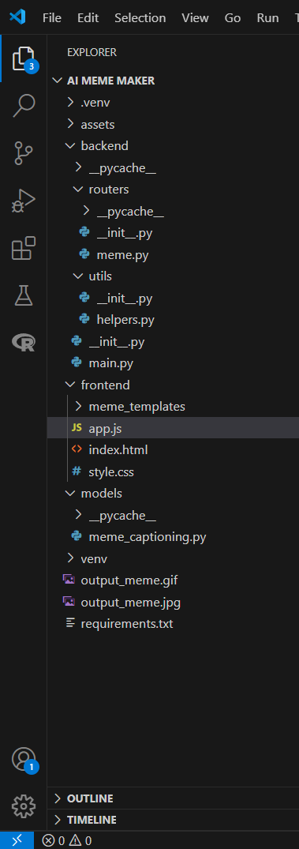

* **backend/main.py** – Initializes FastAPI app, sets up CORS, and includes all API routes.
* **backend/routers/meme.py** – Contains the /generate-meme API route for handling image input and meme creation.
* **backend/utils/helpers.py** – Utility functions for image processing and text formatting.
* **models/meme_captioning.py** – Loads BLIP model and interacts with Mistral (Ollama) for generating AI captions.
* **frontend/index.html** – Web interface for uploading images, generating, and viewing memes.
* **frontend/app.js** – Handles frontend logic like API calls, image preview, and result rendering.
* **frontend/style.css** – Styles the frontend layout, buttons, and meme display.
* **frontend/meme_templates/** – (Optional) Folder for future meme backgrounds or templates.
* **output_meme.jpg / output_meme.gif** – Sample AI-generated meme outputs.
* **requirements.txt** – Lists all Python dependencies required for the project.
* **.venv/** – Virtual environment folder for isolating Python packages.

**Milestone:**

**Milestone 1: Model Selection and Architecture**

This milestone involved careful selection, testing, and integration of AI models for image captioning and caption enhancement, along with establishing a clean project architecture to support modular and scalable development.

* **Activity 1.1:** Loaded the BLIP model using Hugging Face’s BlipProcessor and BlipForConditionalGeneration to convert uploaded images into semantic captions. The model was tested for accuracy on diverse image sets. Mistral was pulled via Ollama and served locally using a RESTful interface, enabling fast, cost-free, and offline inference. BLIP and Mistral were selected after benchmarking various models for accuracy and creativity.

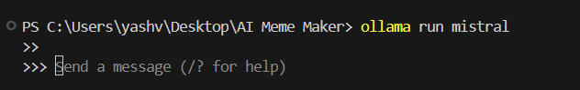



* **Activity 1.2:** Established the system design with modular separation of responsibilities—frontend (for UI), backend (FastAPI logic), and utilities (AI operations and image manipulation). Frontend sends images to the backend, which in turn routes through meme_captioning.py for caption generation and image_utils.py for text overlay.

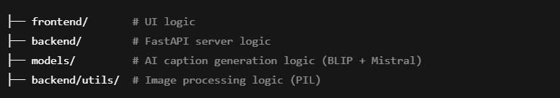

* **Activity 1.3:** Configured a Python environment with dependencies like torch, transformers, Pillow, and uvicorn. Set up FastAPI with CORS, static routes for memes and frontend files, and confirmed Ollama’s readiness to serve inference requests from Mistral on localhost.

**Milestone 2: Core Functionalities Development**

* **Activity 2.1:** Created the generate_caption_from_image() function that accepts an image, applies BLIP’s image encoding pipeline using processor(image, return_tensors='pt'), and runs it through model.generate() to produce a descriptive caption string using processor.decode().

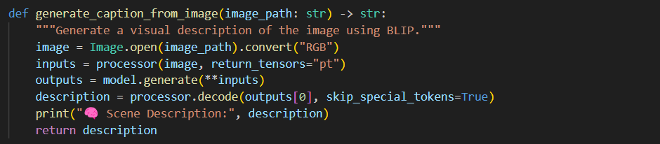

* **Activity 2.2:** Developed generate_funny_meme_text() to craft a prompt string: "You're an expert meme creator. Write a short, funny caption for this image: ". This prompt is passed to Mistral via a POST request to http://localhost:11434/api/generate. The stream response is parsed and returned as the final meme caption

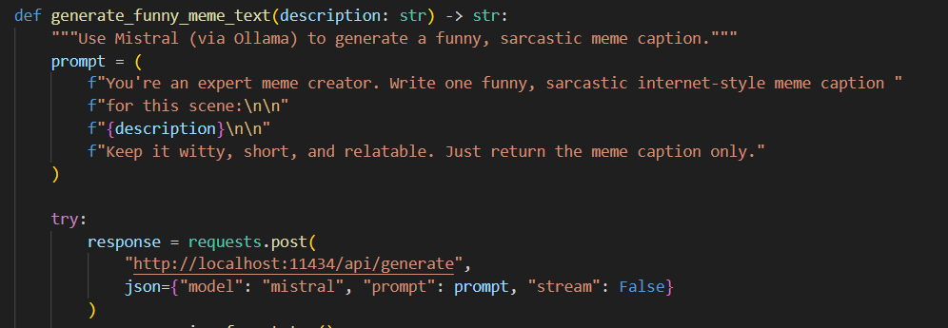

* **Activity 2.3:** Enhanced generate_funny_meme_text() to accept a temperature parameter, which controls the randomness of the generated caption. A slider in the frontend allows users to choose a value between 0.1 and 1.0, enabling them to adjust the humor style—from safe and predictable to bold and creative. The selected value is passed to the backend and included in the POST request to Mistral for caption generation.

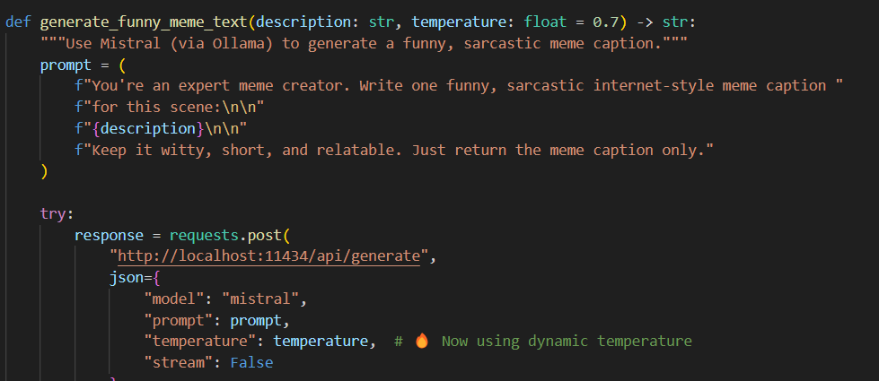

* **Activity 2.4:** Designed create_meme() to overlay text onto images using PIL. Fonts are loaded via ImageFont.truetype, and ImageDraw.text() is used to render the caption with padding and wrapping (textwrap.wrap()). A dual-layer style (black stroke under white text) ensures readability on all backgrounds.

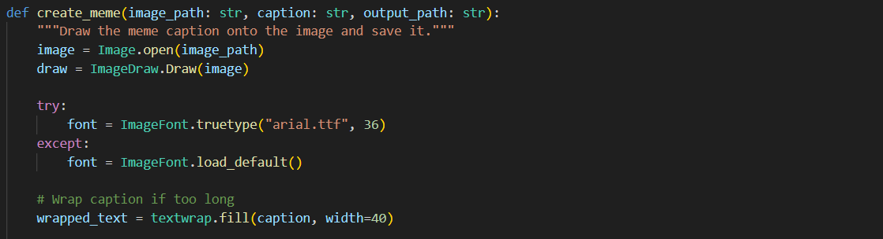

**Milestone 3: Backend API Development**

* **Activity 3.1:** In main.py, FastAPI is initialized with CORS middleware to allow cross-origin requests from the frontend. Static files are served using StaticFiles(directory=...) for frontend/ and static/memes/ folders.

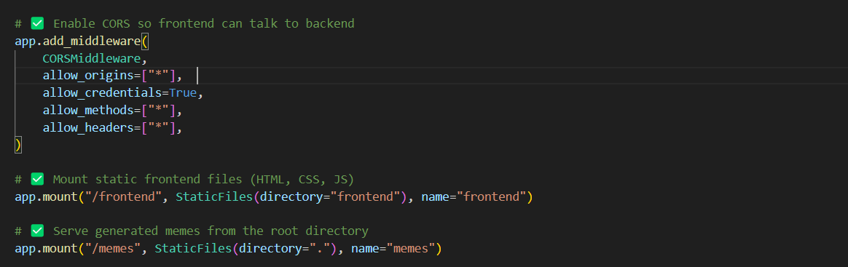

* **Activity 3.2:** Created /meme/generate endpoint inside meme.py. This endpoint accepts multipart/form-data including an image and optional text. If the user provides no caption, it routes through BLIP and Mistral to create one. The image is saved using shutil.copyfileobj() and passed to the meme creation function.

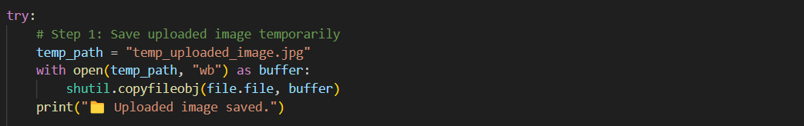

* **Activity 3.3:** Uses FastAPI’s FileResponse() to return the final image path. The generated caption is added to the HTTP header (X-Caption) using the headers parameter of the response, which is captured by the frontend for display.

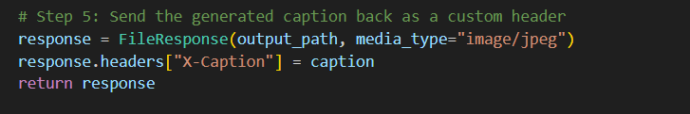

**Milestone 4: Frontend Development**

* **Activity 4.1:** Built a static UI in index.html featuring semantic layout with <form>, <input>, <img>, and <button> elements. The form includes an upload input, caption field, and submit button. Image preview and buttons for caption editing and sharing are included.

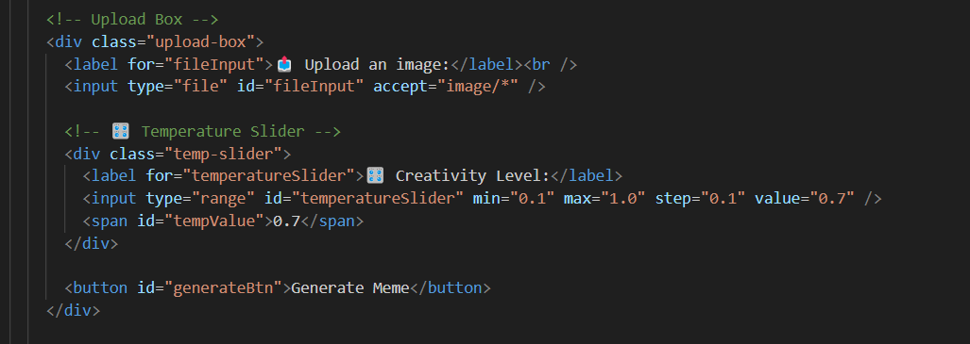

* **Activity 4.2:** app.js handles submit events for the form. It constructs a FormData object with the selected image and caption, then sends a fetch POST request to /meme/generate. Upon response, the returned image is updated in the DOM using UsRL.createObjectURL() and caption is updated from the response header.

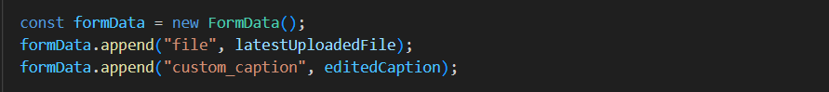

* **Activity 4.3:** Styling in style.css implements Flexbox layout for center alignment, responsive spacing using media queries, styled file input areas, and hover animations for buttons. This ensures consistency and clarity across desktop and mobile displays.

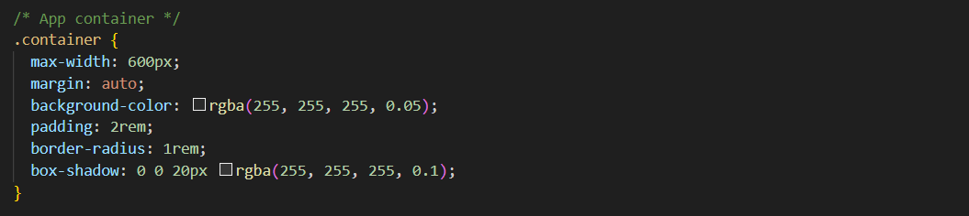

**Milestone 5: Testing and Validation**

* **Activity 5.1:** Used FastAPI’s auto-generated Swagger UI (/docs) to upload test images and verify caption headers and image output through the interface.

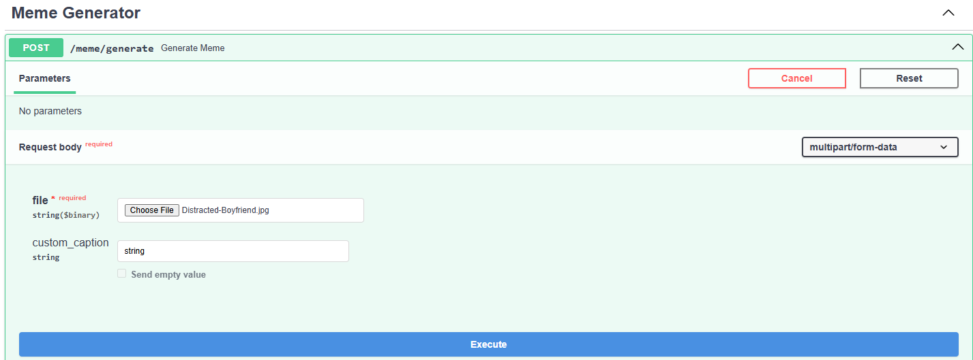

* **Activity 5.2:** Conducted end-to-end tests with different image formats (.jpg, .png, etc.), ensuring BLIP accurately interpreted visuals and Mistral delivered humorous, readable text.
* **Activity 5.3:** Tested edge cases including long captions, empty uploads, and manual caption overrides. Verified the images were saved in static/memes/, correctly served by FastAPI, and loaded via <img> tags in the browser. Social share buttons were validated using mock URLs.

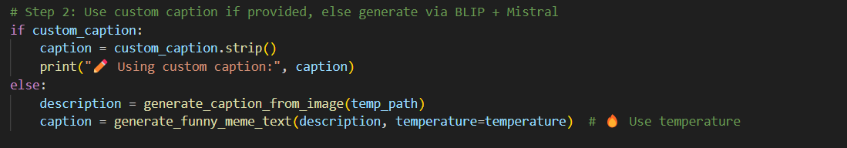

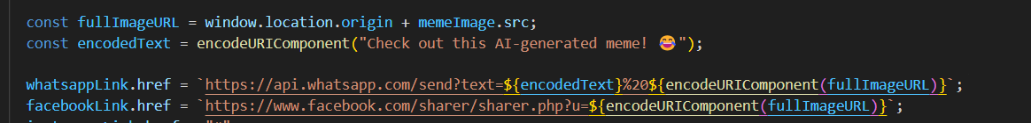

**Frontend Pages Overview:**

* **Home Page:** Provides upload functionality, image preview, caption display, and buttons for generating and sharing memes.
* **Edit Caption:** Allows users to replace the AI-generated caption with a custom one and regenerate the meme.

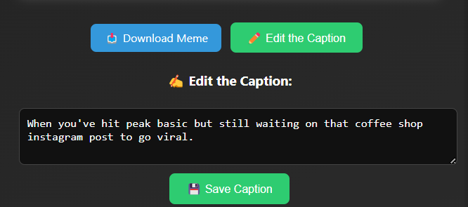

* **Share Buttons:** Dynamic links for WhatsApp and Facebook enable users to share memes directly with a single click.

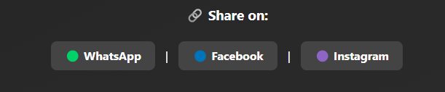

* **Creativity Level:** lets users control the humor style of their meme. Lower values (e.g., 0.2) generate safe and predictable captions, while higher values (e.g., 1.0) create more bold, surprising, and quirky outputs. This slider dynamically adjusts the AI's creativity during caption generation.

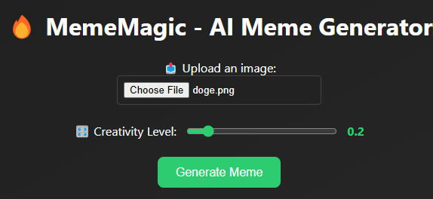

**Project Output:**

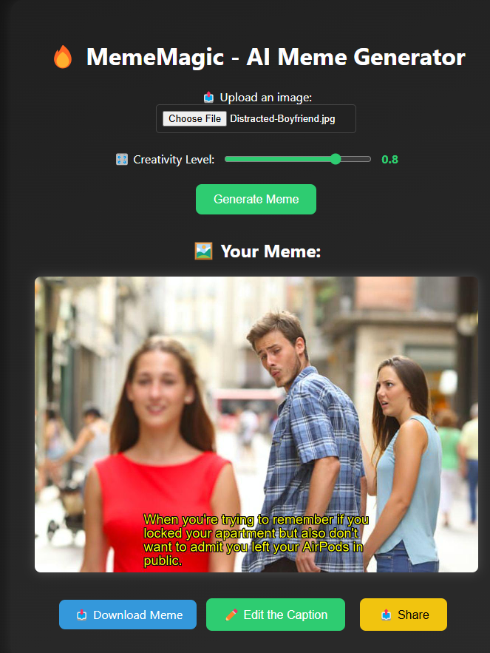

The above image showcases the frontend interface of **MemeMagic – AI Meme Generator**. Users can upload an image and generate a meme using AI-generated captions powered by BLIP and Mistral models. The interface includes a **Creativity Level slider**, allowing users to control the humor style of the generated caption—from safe and straightforward to bold and quirky—by adjusting the AI's temperature setting in real time. The meme is displayed dynamically on the page with options to download, edit the caption, or share it on platforms like WhatsApp, Facebook, and Instagram. The image preview demonstrates a meme created from the popular "Distracted Boyfriend" template, with a witty caption automatically overlaid. This interface combines functionality with clean UI design, offering an intuitive and engaging user experience for meme creation.

**Conclusion:**

MemeMagic successfully showcases the practical power of generative AI by delivering an end-to-end solution for fast, creative, and customizable meme creation. The system merges advanced vision-language models into a seamless workflow, enabling users to turn any image into a humorous, shareable meme within seconds. At its core, the project integrates Salesforce's **BLIP** model for scene understanding and **Mistral**, a local large language model run via **Ollama**, for witty caption generation. Together, these models form a dual-layer AI engine that removes the need for manual creativity while offering the flexibility for user input.

**What Was Achieved:**

The project achieved a fully functional, responsive meme generation platform powered by AI. The **FastAPI backend** handles image upload, AI model inference, and meme rendering using **PIL**, while the **HTML, CSS, and JavaScript frontend** provides a clean, interactive user experience. Key features include:

* Auto-caption generation using BLIP
* Humor enhancement via Mistral
* Editable captions for user creativity
* Styled text overlay using PIL
* Real-time image preview and meme rendering
* One-click sharing to **WhatsApp, Facebook, and Instagram**

Additionally, the system was designed for **modularity and scalability**, with separate utilities for image processing and captioning, and clearly structured backend routing. This architectural clarity ensures easy maintenance and future extension.

**Challenges Faced:**

Several challenges arose during development. Initially, caption formatting and readability on images proved tricky—requiring fine-tuning of **font styles, padding, and text wrapping** using PIL. Another challenge was integrating Mistral locally using Ollama, especially for real-time performance. API communication needed to be optimized to avoid delays during caption generation. On the frontend, maintaining responsiveness across devices and resolving image rendering issues in the browser also required iteration. Finally, ensuring smooth CORS configuration and data exchange between frontend and backend was crucial to maintaining functionality during deployment and testing.

**Learning Outcomes:**

This project deepened practical experience in **computer vision, natural language processing, and web application development**. On the AI side, it enhanced understanding of transformer-based models, Hugging Face pipelines, and local LLM serving with Ollama. Backend development strengthened skills in **FastAPI, CORS, file handling**, and **RESTful API design**, while the frontend provided insights into responsive design, dynamic image rendering, and **client-server integration**. The project also reinforced how modular design accelerates debugging and scalability.

**Future Scope:**

The current version of MemeMagic lays a strong foundation, but several enhancements are envisioned. These include:

* Adding more AI tones: sarcasm, dark humor, pop-culture references
* A **GIF-generation feature** using smooth animated text transitions
* **User authentication and meme history tracking**
* Export to **PDF or gallery formats**
* Support for **preloaded meme templates**
* Deploying as a **PWA** (Progressive Web App) for mobile usability

With growing interest in creative AI tools, MemeMagic is well-positioned for future expansion. By blending automation with human creativity, the platform delivers both technical depth and user delight—proving how AI can enhance modern digital expression.